New sales organization
FAULHABER sets the course for further growth
As of October 1, 2023, FAULHABER is reorganizing its sales division, thereby placing an even stronger focus on customer orientation and responsiveness. Responsibilities will be reallocated within the existing sales management team. This strategic development is a decisive step in taking the company's growth to the next level.

In order to strengthen the sales organization in times of an increasing complexity in international markets, FAULHABER has decided to realign global sales within the experienced team under Managing Director Karl Faulhaber.

Marcus Remmel will take over the area of global market development and will be responsible for the future development of new sales channels and global business development activities. Here, FAULHABER will focus on accounts, target markets and regions with high potential and invest in the development of specialized market know-how in the medical, automation, and robotics markets.
Volker Sprenger, who already manages sales activities and key customers in Germany, will take over key accounts on a global level in the future. In addition, he will further expand FAULHABER's presence in North America. Based on her many years of experience in customer relationship management,
Mireille Deckers-Strobel, who currently heads Global Sales Operations, will also assume responsibility for the sales markets of Europe, China, Asia-Pacific as well as for global direct customers and the distribution network. With their extensive application knowledge, they will drive growth on an international level and consolidate FAULHABER's market position.

"The realignment of the sales organization in the hands of our experienced management team will enable us to strengthen our global sales activities and create new momentum. We want to support our customers in realizing the innovative power of future markets with products from FAULHABER," says Managing Director Karl Faulhaber.

About FAULHABER
FAULHABER is an independent, family-run group of companies headquartered in Schönaich near Stuttgart, Baden-Württemberg. Founded in 1947, FAULHABER today boasts the largest range of highly developed miniature and micro drive technology which is available worldwide from a single source.
Using this wide variety of technologies, the company designs drive solutions that are unrivalled when it comes to precision and reliability in very small spaces. The main areas of use include production automation and robotics, aerospace, optical systems as well as medicine and laboratory technology.
In addition to Germany, FAULHABER maintains development and production locations in Switzerland, USA, Romania and Hungary. Moreover, there are sales partners and subsidiaries in more than 30 countries around the world.
 | 408 words / 2.798 characters
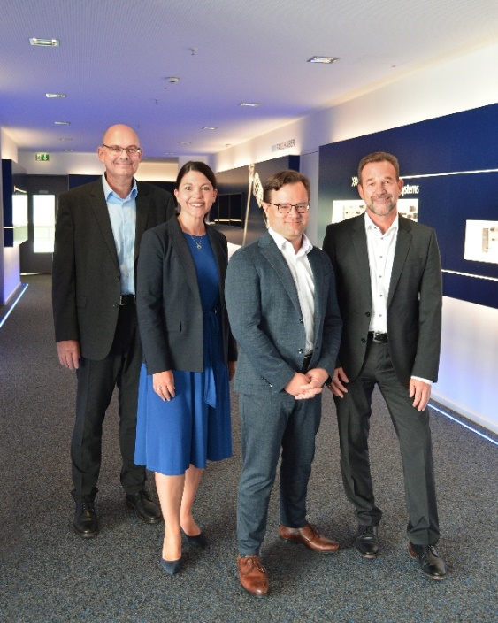 | f.l.t.r.: Marcus Remmel, Mireille Deckers-Strobel, Karl Faulhaber, Volker Sprenger © FAULHABER

Press contact (Germany + International)  Dr. Fritz Faulhaber GmbH & Co. KG  Kristina Wolff – Marketing  Faulhaberstraße 1 · 71101 Schönaich  Germany  T +49 7031 638-148 · F +49 7031 638-8148  redaktion@faulhaber.com | Press contact (Switzerland)  FAULHABER SA  Ann-Kristin Hage-Ripamonti – Marketing  6980 Croglio  Switzerland  T +41 91 61 13 239 · F +41 91 611 31 10  marketing@faulhaber.ch

