Schönaich, April 1, 2023
Motion Controllers for miniature drives and microdrives
New family member for the medium power range
FAULHABER has added another extremely compact Motion Controller without housing to its product range. The new Motion Controller is ideal for integration in equipment manufacturing and medical technology applications. With 36 V and 3 A (peak current 9 A), it covers the power range up to approx. 100 W and is suitable for DC-motors with encoder, brushless drives or linear motors.
Miniature motors and micromotors only become a reliable drive system when combined with the matching Motion Controller. This is why the extensive range of motors offered by the drive specialist FAULHABER (see company box) includes a broad selection of Motion Controllers which are designed in different power classes with or without housing for a wide variety of applications. There is now a new addition to the family of Motion Controllers without housing: The MC3603 (Fig. 1) which owing to its compact size is ideal for integration in equipment manufacturing and medical technology applications. With 36 V and 3 A (peak current 9 A), the new Motion Controller covers the medium power range up to approx. 100 W. It is suitable for "normal" DC-motors with encoder, brushless drives and linear motors. The I/O options and encoder interfaces are the same as the rest of the product family. USB, RS232, CANopen and EtherCAT are available for communication. The Motion Controller already has the new firmware version "M". To ensure simple and convenient system setup, the latest update (version 6.9) of the FAULHABER Motion Manager should be used.
EMC-compliant design for all Motion Controllers
With the introduction of the new MC 3603, the Motion Controllers now cover the entire application range typical for miniature motors and micromotors (Fig. 2), starting with the postage stamp sized MC 3001 with 30 W and 1 A (peak current 2 A) through to the MC 5010, the largest member of the family with 10 A (peak current 30 A), which is designed for installation in switching cabinets and has been tried and tested primarily in the industrial sector. All motion controllers comply with current EMC regulations. This is why the drive specialists have explored this complex topic in great detail. Not only has the hardware been appropriately optimized, but the documentation has also been redesigned to provide users with the best possible support during the certification of their own devices.
Further information on EMC: www.faulhaber.com/de/motion/faulhaber-veroeffentlicht-fachbuch/

Link to book: https://vogel-fachbuch.de/elektrotechnik/energietechnik/919-elektromagnetische-vertraeglichkeit-von-elektrischen-kleinantrieben

[278 words / 2,076 characters]
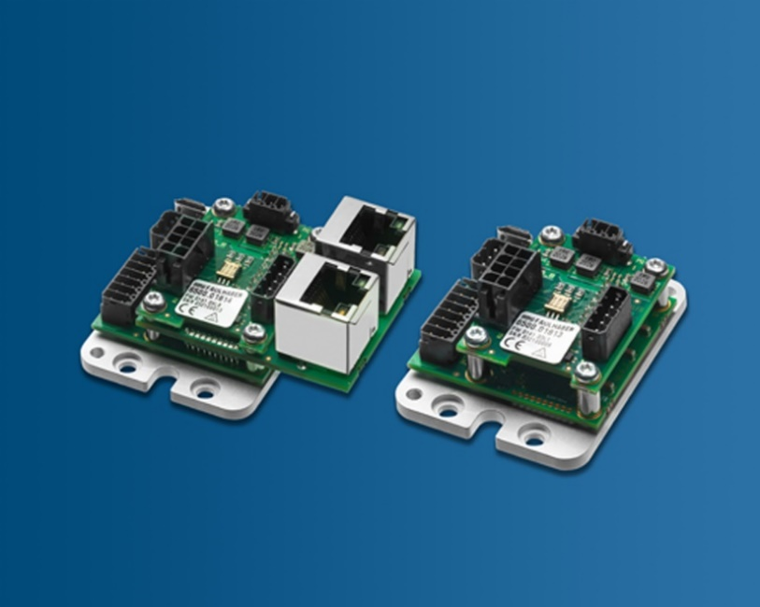 | [Figure 1]  New family member for the medium power range up to approx. 100 W: The compact dimensions of the MC3603 make it especially suitable for integration in equipment manufacturing and medical technology applications. © FAULHABER

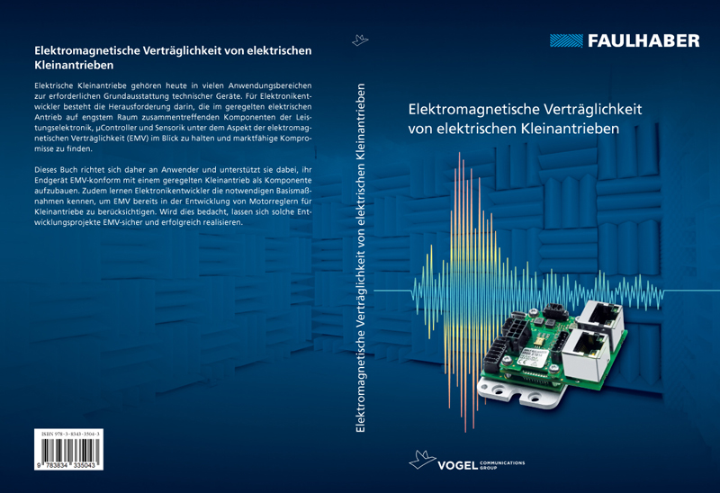 | [Figure 2]  Motion controllers for various application areas. They comply with current EMC regulations. The detailed documentation supports the user during the certification of his own devices.© FAULHABER

Press contact (Germany + International)  Dr. Fritz Faulhaber GmbH & Co. KG  Kristina Wolff – Marketing  Faulhaberstraße 1 · 71101 Schönaich  Germany  T +49 7031 638-148 · F +49 7031 638-8148  redaktion@faulhaber.com | Press contact (Switzerland/Italy)  FAULHABER Minimotor SA  Ann-Kristin Hage-Ripamonti – Marketing  6980 Croglio  Switzerland  T +41 91 61 13 239 · F +41 91 611 31 10  marketing@faulhaber.ch

