FAULHABER Motors Romania S.R.L is extending production location in Jimbolia
New building with diverse production possibilities
With the extension of its production location in Jimbolia, Romania, the FAULHABER Group is taking a significant step to boost its competitiveness on the market and at the same time to satisfy the growing demand for its high-quality products.

FAULHABER Motors Romania S.R.L with around 170 employees and a production area of 2,850 square meters has been active in Jimbolia in Timis County, Romania, since 2005. The production site is a key element of the manufacturing network of the FAULHABER Group. Important skilled manual activities such as gearhead assembly or balancing processes are performed there. Windings for FAULHABER bell-type armature motors are manufactured at the site too. Furthermore, the range of services also includes the manufacture of modules as well as the assembly of customer-specific complete drive systems.

Production hall compliant with FAULHABER standards
To safeguard the competitiveness of the FAULHABER Group in the long term, the company is extending this site. The relocation of new projects is one of the principal reasons for this measure. The extension will cover an area of 5,000 square meters, whereby 3,800 square meters are intended for production. The remaining area will be used for warehousing and administration.
According to the structural plans, the new production hall is based on a metal construction fitted out in compliance with FAULHABER standards. This extension will considerably increase production capacity at the location in order to meet growing demands. In addition to the increase in surface area, there will also be a significant increase in the number of employees at the location. This measure will create new jobs and boost the local economy in the Jimbolia region.

Diverse production possibilities
The new building will provide a wide range of production possibilities. Apart from modules for motors, the location will also produce motors and finished goods that are used in various industries such as medicine, aviation and automation. Furthermore, other products are also planned in order to meet the ever-changing needs of customers.
Extension of the production location in Jimbolia is a key step for the FAULHABER Group as it will enable the company to boost its competitiveness on the market and to satisfy the growing demand for high-quality products. FAULHABER is confident that the extension will be successful and will have a positive impact both on the local economy and on the employees.

About FAULHABER Motors Romania S.R.L
FAULHABER Motors Romania S.R.L is part of the international FAULHABER Group and has been producing high-quality motors and drive systems in Jimbolia, Romania, since 2005. The company attaches great importance to quality, innovation and customer satisfaction.

About FAULHABER
FAULHABER is an independent, family-run group of companies headquartered in Schönaich near Stuttgart, Baden-Württemberg. Founded in 1947, FAULHABER today boasts the largest range of highly developed miniature and micro drive technology which is available worldwide from a single source.
Using this wide variety of technologies, the company designs drive solutions that are unrivalled when it comes to precision and reliability in very small spaces. The main areas of use include production automation and robotics, aerospace, optical systems as well as medicine and laboratory technology.
In addition to Germany, FAULHABER maintains development and production locations in Switzerland, USA, Romania and Hungary. Moreover, there are sales partners and subsidiaries in more than 30 countries around the world.
 | 560 words / 3,696 characters
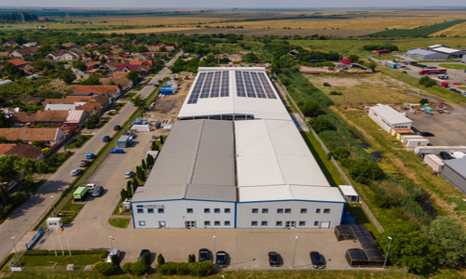 | FAULHABER Motors Romania S.R.L is extending production location in Jimbolia© FAULHABER

Press contact (Germany + International)  Dr. Fritz Faulhaber GmbH & Co. KG  Kristina Wolff – Marketing  Faulhaberstraße 1 · 71101 Schönaich  Germany  T +49 7031 638-148 · F +49 7031 638-8148  redaktion@faulhaber.com | Press contact (Switzerland)  FAULHABER SA  Ann-Kristin Hage-Ripamonti – Marketing  6980 Croglio  Switzerland  T +41 91 61 13 239 · F +41 91 611 31 10  marketing@faulhaber.ch

